Homework 3

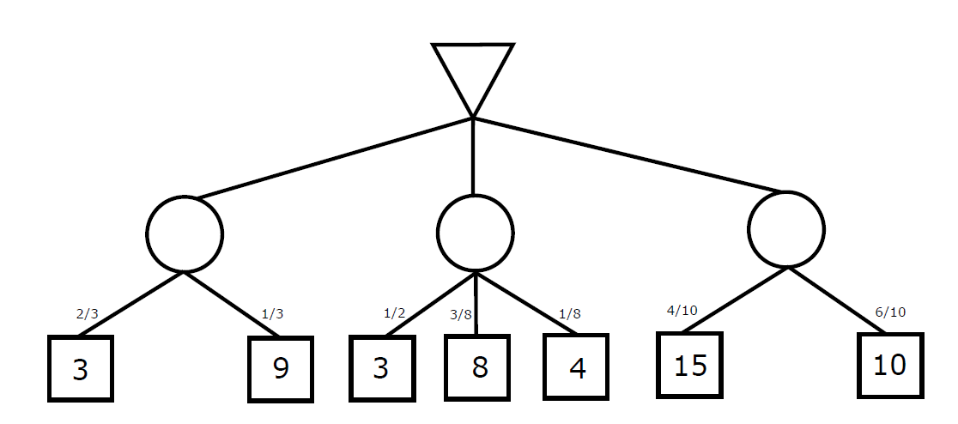
- Consider the above expectiminimax tree, where circle nodes are chance nodes, the top node is a min node, and the bottom nodes represent the terminal utilities.
5
12
5
5

- Calculate the value of each chance node, as per expectiminimax definition.
- What is the value of the min node? Which action should the min player take (e.g., first, second, or third action represented by a chance node)?
The value of the min node is 5, the min player could take either the first or the second action since they both have the same value.
- Which nodes can be pruned from the game tree above through alpha-beta pruning? Explain the reason if no nodes can be pruned.
No nodes can be pruned since we don’t have deterministic values, all the chance nodes have to be calculated to determine their value.

- Using the full joint distribution shown on page 499, Figure 13.3, calculate the probabilities below. Notice that P without boldface means a probability value and the boldface variable P means a probability distribution.

- P(toothache) = 0.2 = 20%
- P(catch): = 0.34 = 34%
- P(Cavity):
Cavity | P
Toothache | .2
¬Toothace | .8

- P(Toothache | catch):
Divide by 0.34
Toothache | Catch | P
Toothache | Catch | 0.124
Toothache | ¬Catch | 0.076
¬Toothache | Catch | 0.216
¬Toothache | ¬Catch | 0.584
T | C | P
Catch | 0.365
¬Catch | 0.635

- P(Cavity | toothache V catch):
Divide by 0.416
Cavity | Toothache | P | ∨ Catch
Cavity | Toothache | 0.12 | 0.192
Cavity | ¬Toothache | 0.08 | 0.188
¬Cavity | Toothache | 0.08 | 0.224
¬Cavity | ¬Toothache | 0.72 | 0.736
C | T ∨ C | P
True | 0.462
False | 0.538

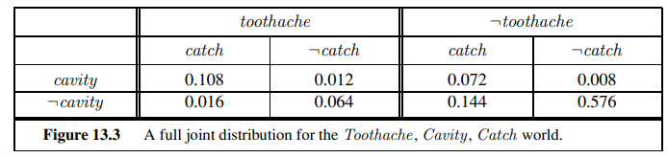

- This exercise will help you reinforce the concept of normalization. It is based on the calculation for the meningitis example on page 503. First, consider a suitable value for P(s|¬m), and use it to calculate unnormalized values for P(m|s) and P(¬m|s) (i.e., ignoring the P(s) term in the Bayes’ rule expression in Equation 13.14). Now, normalize these values so that they add up to 1.
P(s|m) = 0.65
P(s|¬m) = 0.35
P(m) = 1/20,000
Normalizing value = 400
P(m|s) * 400 = 0.65
P(¬m|s) * 400 = 0.35
P(s) = 0.02
P(m|s) = $\frac{0.65(\frac{1}{20000})}{0.02}$ = 0.001625
P(¬m|s) = $\frac{0.35(\frac{1}{20000})}{0.02}$ = 0.000875
- Programming Assignment:
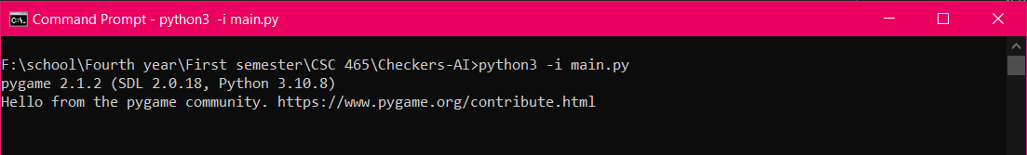
When increasing the depth value of the minimax tree, the wait time for the response of algorithm increased.
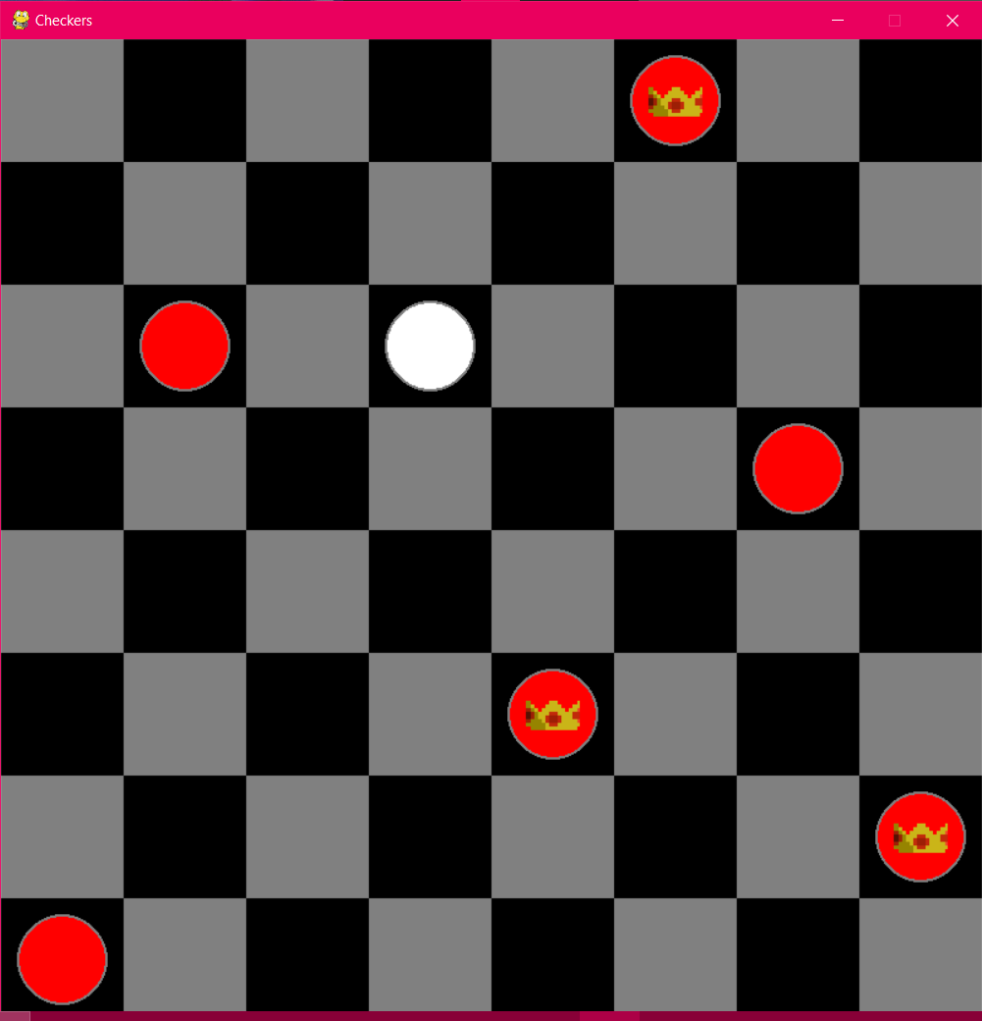
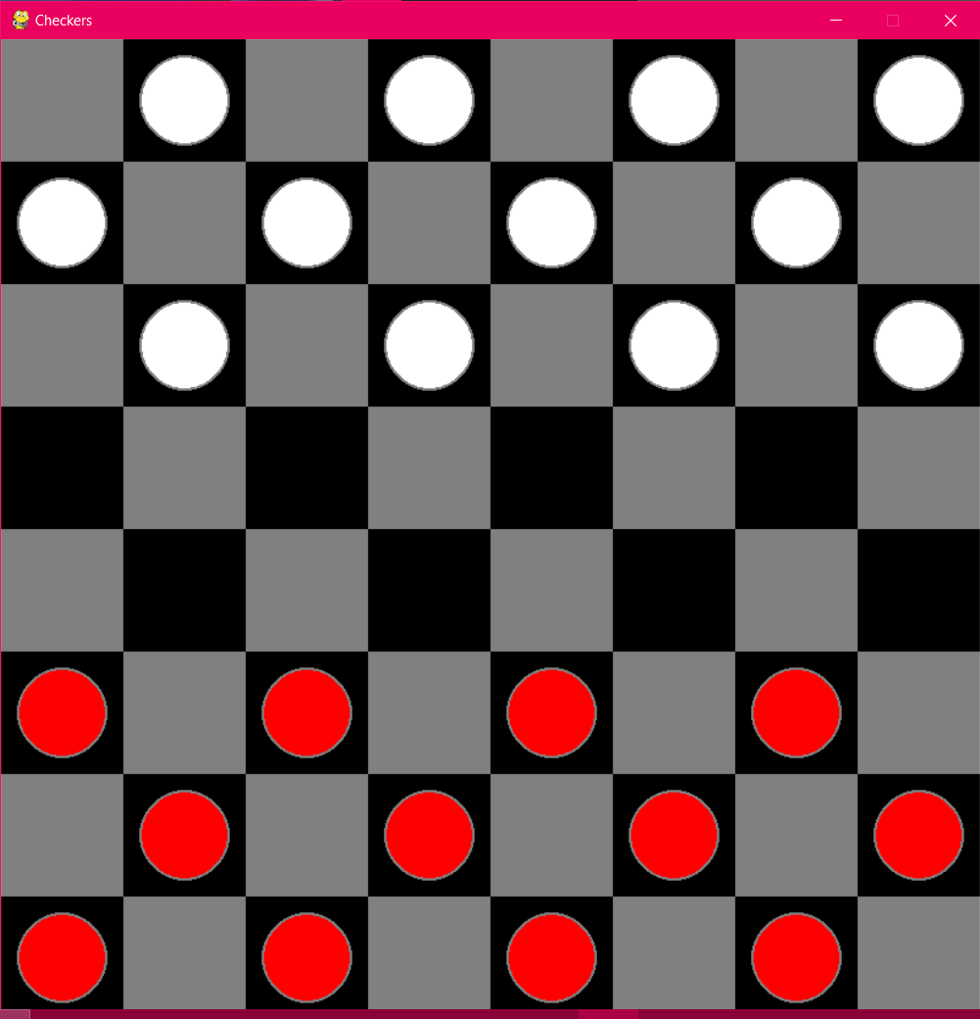
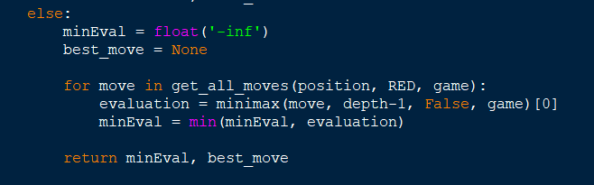

- Wumpus
- Consider the following Wumpus World state:
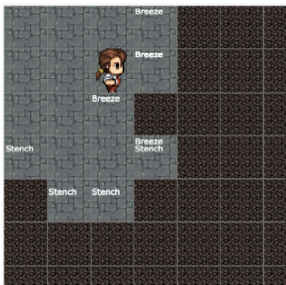
Our knowledge base of this map entails that there should be a pit directly southeast of the character, since there are three Breeze squares surrounding it. The same reason holds for the two bottom squares surrounded by Stench, indicating that there should be a Wumpus in those.

A state that could be satisfied is if the character started moving right, he can keep doing so only if there is no Stench or Breeze squares along the way.

There should be a Wumpus directly southeast of the character, as well as a pit northeast from him.

He should be safe walking into the square he is facing, since there are no Stench or Breeze squares surrounding it.

He should be able to uncover most of the bottom right squares without any consequence.

There is no clear way of deducing which path is the safe one, definitely the first two squares from the left should be avoided.

